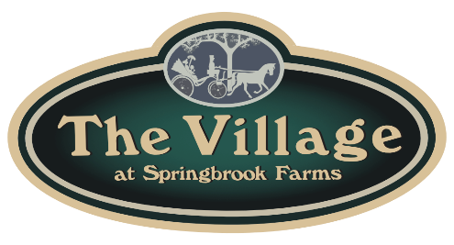
The Townes in the Village at Springbrook Farms
PO Box 445 Palmyra, PA 17078 ~717.774.7791~

DRYER CLEANING CERTIFICATION

☐ Homeowner ☐ Landlord ____________________________________________________________

Unit # & Street: _____________________________ Email: _____________________________________

Contact Phone: __________________ Address if not a Unit: ____________________________________

I confirm on (Date) _____________ my dryer was cleaned by (Company) __________________________

For Technician: ☐ Yes ☐ No The Unit has a booster fan.
☐ Yes ☐ No The homeowner is keeping the booster fan and had it cleaned today.
☐ Yes ☐ No The homeowner had the booster fan removed today.
☐ Yes ☐ No The dryer vent cage on the outside of the home was replaced today.

_______________________________________________________________________________________Homeowner Signature Technician Signature

For Homeowners:

☐ Please print this form out and complete your part.
☐ Have the technician complete his/her part of this form.
☐ Please email this form and a copy of your paid invoice to: springbrookfarms@deangelore.com
_____ OR _____

☐ Put this completed form and a copy of your paid invoice in an envelope addressed on the front to “Dryer Cleaning Forms,” and place it in one of the Townes’ drop boxes as illustrated below.

Thank you for helping keep our community safe.

“DRYER CLEANING FORMS”

Drop Box #1 is on Brookwood Drive near the entrance from Northside Drive.

Drop Box #2 is on Brookwood Drive near the entrance from Hinkle Road.

