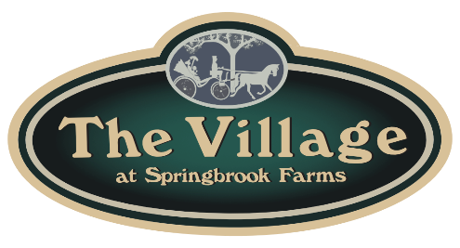
The Townes in the Village at Springbrook Farms
PO Box 228 Palmyra, PA 17078 ~717.930.6061~

COMPLETE DRYER CLEANING
HOMEOWNER & PROVIDER CERTIFICATION

Homeowner/Landlord:

Unit Address:

Contact Phone: Email:

Mailing Address if Different than Unit Address:

I hereby certify that on (date) my dryer vent, duct, and hoses were cleaned by: (name, phone, email, and website of Professional Provider if available)

For Technician:

The Unit has a blower fan. YES NO

The Unit has a blower fan, the owner agrees to keep it, and it has been cleaned. YES NO

The Unit has a blower fan and the owner agrees to remove it. YES NO

The dryer vent cage on the outside was replaced. YES NO

HOMEOWNER SIGNATURE TECHNICIAN SIGNATURE

Payment made by: Check # ______ Cash $ ______ Credit Card ________________________

- Homeowners should complete their part of this form and give it to the Technicians to complete their part when the cleaning is done.

- The Technicians will keep one copy of this form in their office along with a paid receipt.

- Homeowners should keep one copy of this form and a paid receipt with their home maintenance records. Homeowners should also scan and email the completed form and receipt to:
townesdryerventcleaning@gmail.com
If Homeowners cannot email the form and receipt, please call the HOA Board Secretary at 717-641-3994 to make arrangements to deliver it.

Form Created 9/2022

